RAJALAKSHMI ENGINEERING COLLEGE
RAJALAKSHMI NAGAR, THANDALAM – 602 105



CS23633 – Cloud Computing
Laboratory Record Note Book



DEPARTMENT OF COMPUTER SCIENCE AND ENGINEERING

CS23633 – Cloud Computing

NAME | Kasilingam M
ROLL NO | 230701145
YEAR | III
DEPT | CSE


RAJALAKSHMI ENGINEERING COLLEGE
An Autonomous Institution

BONAFIDE CERTIFICATE

Name: ………………………………………………………………………
Academic Year: ……… Semester: …….. Branch: ……………………...
Register No.

Certified that this is the bonafide record of work done by the above student in the……………………………………………………………………………… Laboratory during the academic year 2025 – 2026.

Signature of Faculty in-charge
Submitted for the Practical Examination held on
………………………..

Internal Examiner External Examiner
INDEX

S. No. | Experiment | Date | GitHub
1 | Private Cloud Using OpenStack | 05.02.2026 | 
2 | Public Cloud: Develop A Simple Application Using PaaS | 05.03.2026
3 | Hybrid Cloud | 13.03.2026
4 | Backup Automation Using Azure Blob Storage | 30.04.2026
5 | VPS / Virtual Machine Setup and Linux Configuration | 30.04.2026

EXPT NO. 1 – PRIVATE CLOUD USING OPENSTACK

Aim:
To design, install, and configure a Private Cloud environment using a single-node OpenStack (MicroStack) implementation, and to understand the basic cloud services such as compute, networking, and storage by deploying and accessing virtual machine instances on the private cloud.

OPENSTACK:
Theory:
What is OpenStack?
- OpenStack is a free, open standard cloud computing platform.
- It is mostly deployed as Infrastructure-as-a-Service (IaaS).
- OpenStack allows to deploy virtual machines (VMs) on demand.

It controls large pools of:
- Compute
- Storage
- Networking resources of a datacentre

Managed by admins via dashboard – provides resources to users via web interface.
Private/Hybrid cloud → OpenStack
Public cloud → AWS, Azure...

What is MicroStack?
- MicroStack runs OpenStack locally with minimal setup (single-node).
- Ideal for learning, testing, or small development projects.
- Easy to deploy and test OpenStack on a single machine (laptop or small server).

OpenStack Services:
- Nova (Compute)
- Neutron (Networking)
- Keystone (Identity)
- Glance (Images)
- Horizon (Dashboard)

Function | OpenStack | AWS | Description
Compute (VMs) | Nova | EC2 | Run virtual machines
Image Management | Glance | AMI | Store and manage VM images
Identity & Access | Keystone | IAM | User authentication, authorization, roles
Networking | Neutron | VPC, SecurityGrp | Manage networks, routers, IPs, firewalls
Block Storage | Cinder | EBS | Persistent volumes for VMs
Object Storage | Swift | S3 | Store and retrieve unstructured data
Dashboard (UI) | Horizon | AWS Console | Web interface for managing cloud resources

Procedure:
Installation Steps (Ubuntu 22.04 LTS):
sudo snap install microstack –beta
snap list microstack
sudo apt install python-is-python3
sudo microstack init --auto –control

Open browser and navigate to: 10.20.20.1 — the dashboard will appear.
Username: admin
To retrieve the password:
sudo snap get microstack config.credentials.keystone-password

Output:

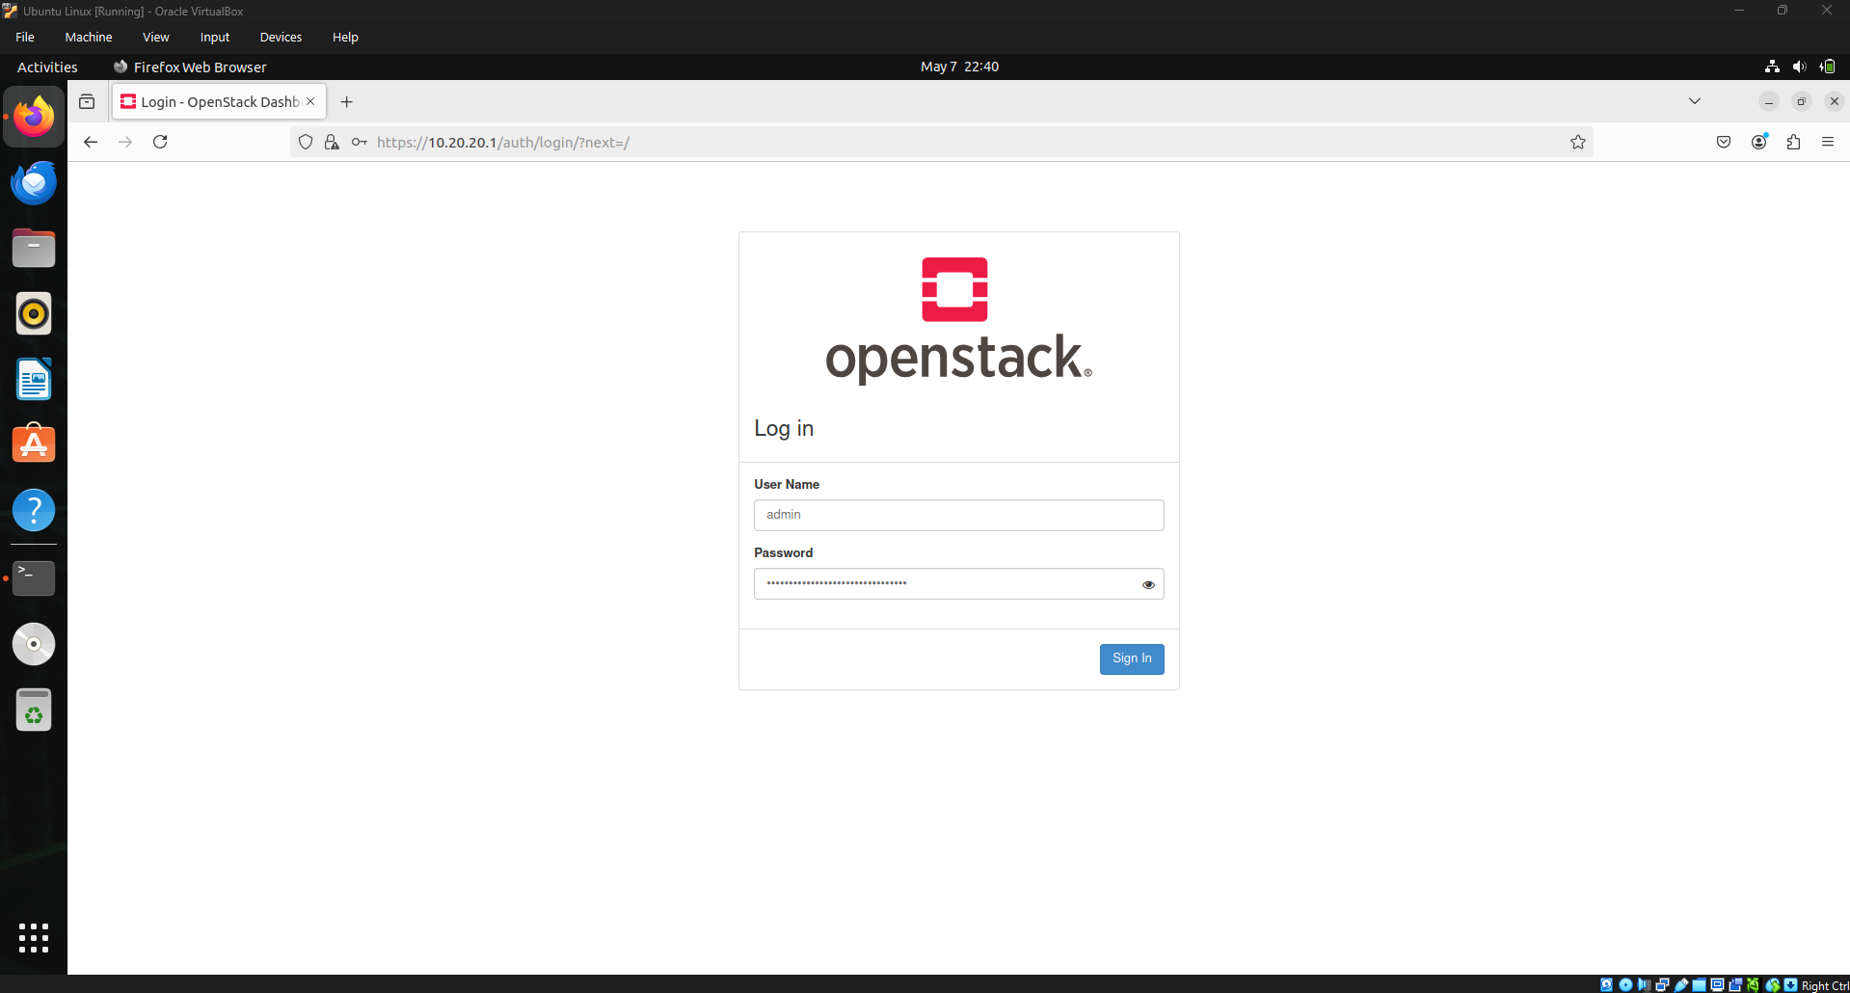

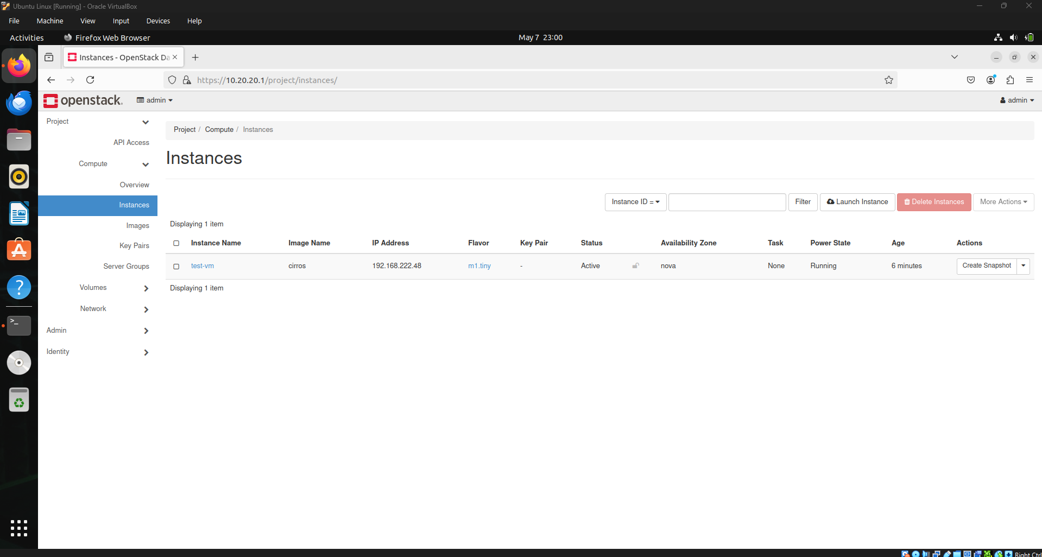

Result:
A single-node Private Cloud environment was successfully set up using OpenStack (MicroStack). The OpenStack services were properly installed and configured, and the private cloud was able to launch, manage, and access virtual machine instances with functional compute, networking, and storage services, thereby meeting the objectives of the experiment.
EXPT NO. 2 – PUBLIC CLOUD: DEVELOP A SIMPLE APPLICATION USING PAAS
Aim:
To develop and deploy a simple web application on Microsoft Azure App Service to understand Platform as a Service (PaaS).

Procedure:
STEP 1: Create Azure Student Free Account
- Open: https://portal.azure.com
- Login with Microsoft account.
- Activate Azure for Students
- After activation → Azure Portal Dashboard opens.

STEP 2: Create a Simple Web Application
- Create a folder on your PC:
azure-app
- Create file: index.html
<!DOCTYPE html>
<html>
<head>
<title>My Azure PaaS App</title>
</head>
<body>
<h1>Hello from Microsoft Azure PaaS!</h1>
<p>This app is deployed using Azure App Service.</p>
</body>
</html>
STEP 3: Create App Service in Azure (PaaS)
- Go to Azure Portal → Click Create a resource
- Search → App Service
- Click → Create

Fill Details:
Project Details
- Subscription: Azure for Students
- Resource Group: Create new → RG-PaaS-Lab
Instance Details
- App name: my-paas-app-12345 (must be unique)
- Publish: Code
- Runtime stack: Choose .NET / Node.js / Python (For HTML → choose .NET or Node.js)
- Region: Central India (or nearby)
Pricing Plan
- Click Change size → Select Free (F1)
Click → Review + Create → Create
Wait 1–2 minutes.

STEP 4: Deploy the Application (Upload Code)
Method 1 (Easy): Deployment Center (ZIP Upload)
- Open your App Service
- Click → Deployment Center
- Select → ZIP Deploy
- Zip your folder azure-app
- Upload ZIP file
Method 2 (Alternative): App Service Editor
- Go to App Service → Advanced Tools (Kudu)
- Click → Go
- Open Debug Console → CMD
- Go to site/wwwroot
- Upload index.html

STEP 5: Run the Application
- Go to App Service → Overview
- Copy the URL:
Example: https://my-paas-app-12345.azurewebsites.net
- Paste in browser
STEP 6: Verify PaaS Concept
Observe:
- No server installation
- No OS configuration
- Azure manages infrastructure
- Only code is deployed
This proves PaaS.

Output:

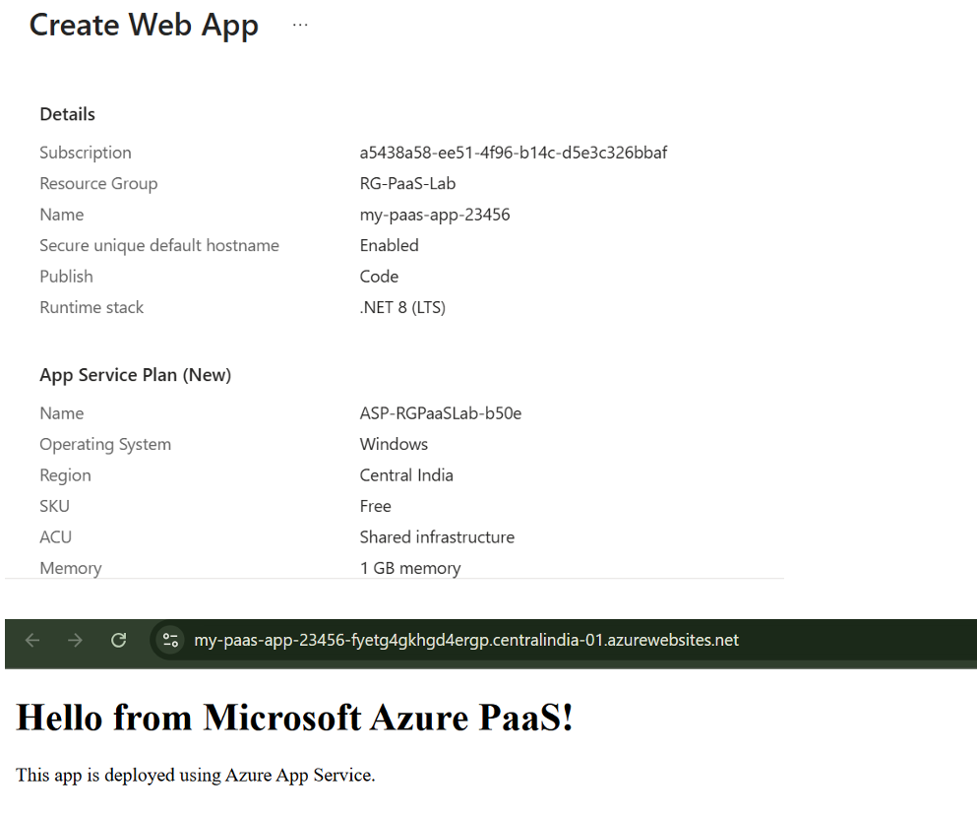

Result:
The simple web application was successfully deployed using Microsoft Azure App Service, demonstrating the concept of Platform as a Service (PaaS).

EXPT NO. 3 – HYBRID CLOUD

Aim:
To set up a secure VPN connection between an on-premises data center and a public cloud provider such as AWS or Azure, and configure a hybrid network topology using virtual private clouds (VPCs), subnets, and route tables.

Steps Overview:
- Create a Virtual Network (VNet)
- Create Subnets
- Create a VPN Gateway
- Simulate an "On-Prem" network
- Connect them using Site-to-Site VPN

Procedure:
STEP 1: Create a Resource Group
Think of Resource Group as a folder.
- Login to Azure Portal
- In search bar type Resource groups
- Click → Create
- Fill:
- Subscription → Your student subscription
- Resource group name → Hybrid-RG
- Region → Choose same region everywhere (example: Central India)
- Click Review + Create
- Click Create

STEP 2: Create Virtual Network (VNet)
VNet = Your cloud network.
- Search Virtual Networks
- Click Create
- Fill:
Basics Tab
- Resource Group → Hybrid-RG
- Name → Cloud-VNet
- Region → SAME region as resource group
Click Next

IP Addresses Tab
- Address Space: 10.1.0.0/16
- Remove default subnet.
Click + Add Subnet

Create Subnet 1:
- Name: App-Subnet
- Address range: 10.1.1.0/24
Click Add

IMPORTANT: Add Gateway Subnet
Click + Add Subnet again:
- Name: GatewaySubnet (must be EXACT name)
- Address range: 10.1.255.0/27
Click Add → Click Review + Create → Click Create
VNet created.

STEP 3: Create Virtual Network Gateway (VPN Gateway)
This is the Azure side VPN device.
- Search → Virtual network gateways
- Click → Create
Fill Details – Basics:
- Resource Group → Hybrid-RG
- Name → Azure-VPN-Gateway
- Region → Same region
- Gateway Type → VPN
- VPN Type → Route-based
- SKU → Select VpnGw1 (basic supported)
- Generation → Generation1

Virtual Network Section
Select: Cloud-VNet
Public IP Address
Click Create new
Name it: VPN-Gateway-IP
Click OK → Click Review + Create → Click Create
IMPORTANT: This takes 30–45 minutes to deploy. Be patient.

STEP 4: Simulate On-Prem Network
Since you don't have a real data center, we simulate. We create a Local Network Gateway (represents on-prem).
- Search → Local Network Gateways
- Click → Create
Fill:
- Resource Group → Hybrid-RG
- Name → OnPrem-Gateway
- Region → Same region
IP Address:
Put any dummy public IP (example): 1.1.1.1
Address Space:
Add: 192.168.1.0/24
Click Review + Create → Click Create
Done.

STEP 5: Create VPN Connection
Now connect Azure to On-Prem.
- Go to Virtual Network Gateways
- Click your gateway → Azure-VPN-Gateway
- On left side click Connections
- Click + Add
Fill:
- Connection Name → Hybrid-Connection
- Connection Type → Site-to-Site (IPsec)
- Virtual Network Gateway → Auto selected
- Local Network Gateway → OnPrem-Gateway
- Shared Key → Type simple password: Azure123
Click OK
VPN connection created.

STEP 6: Verify Connection
- Open Azure-VPN-Gateway
- Click Connections
- Check Status
If configured with real on-prem router → it will show Connected.
Since we used dummy IP, it will show Not Connected.

Output:
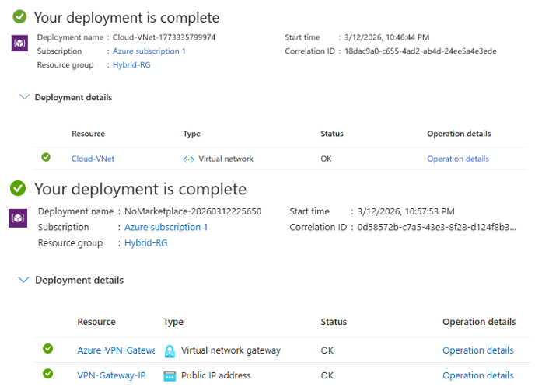
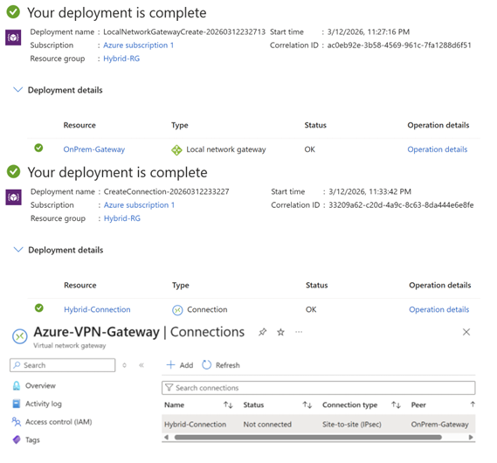

Result:
A hybrid cloud connectivity was successfully set up using Azure Virtual Network Gateway and a simulated on-premises Local Network Gateway connected via a Site-to-Site IPsec VPN tunnel.

EXPT NO. 4 – BACKUP AUTOMATION USING AZURE BLOB STORAGE
Aim:
To design and implement an automated backup solution using Azure Blob Storage and scheduling tools.

Theory:
Azure Blob Storage is a cloud-based object storage service used to store large amounts of unstructured data such as files, backups, logs, and media. It provides high availability, scalability, and secure storage for backup and disaster recovery solutions.

Procedure:
STEP 1: Create Azure Storage Account
- Login to Azure Portal: https://portal.azure.com
- Click Create a resource
- Search Storage Account → Click Create
- Fill the following details:
- Subscription: Azure Student Subscription
- Resource Group: Create new (backup-rg)
- Storage Account Name: mystoragebackup123
- Region: South India
- Performance: Standard
- Redundancy: Locally Redundant Storage (LRS)
- Click Review + Create → Create

STEP 2: Create Blob Container
- Open Storage Account
- Go to Data Storage → Containers
- Click + Container
Fill:
- Name: backups, Public Access: Private
- Click Create
STEP 3: Azure CLI Login
az login # Opens browser for authentication
az account show # Verify account details

STEP 4: Upload Files
az storage blob upload-batch \
--account-name mystoragebackup123 \
--destination backups \
--source C:\backup-data
# Uploads all local files to Azure

STEP 5: Create Backup Script
$source = "C:\backup-data"
$container = "backups"
az storage blob upload-batch `
--account-name mystoragebackup123 `
--destination $container `
--source $source

# Automates backup process

STEP 6: Add Timestamp Backup
$date = Get-Date -Format "yyyy-MM-dd"
$destination = "backups/$date"
az storage blob upload-batch `
--account-name mystoragebackup123 `
--destination $destination `
--source C:\backup-data

# Stores backup by date

STEP 7: Scheduling using Windows Task Scheduler (Detailed)
Steps:
- Press Windows + R
- Type: taskschd.msc
- Press Enter
- Click Create Basic Task
- Enter:
- Name: AzureBackupTask
- Description: Daily Azure Backup
- Click Next
Set Trigger
Choose: Daily
Set time (e.g., 2:00 AM)
Click Next
Set Action
Choose: Start a Program
Configure Program
powershell.exe
Add Arguments:
-ExecutionPolicy Bypass -File "C:\scripts\backup.ps1"
Start In:
C:\scripts
Finish
Click Next → Finish

Output:
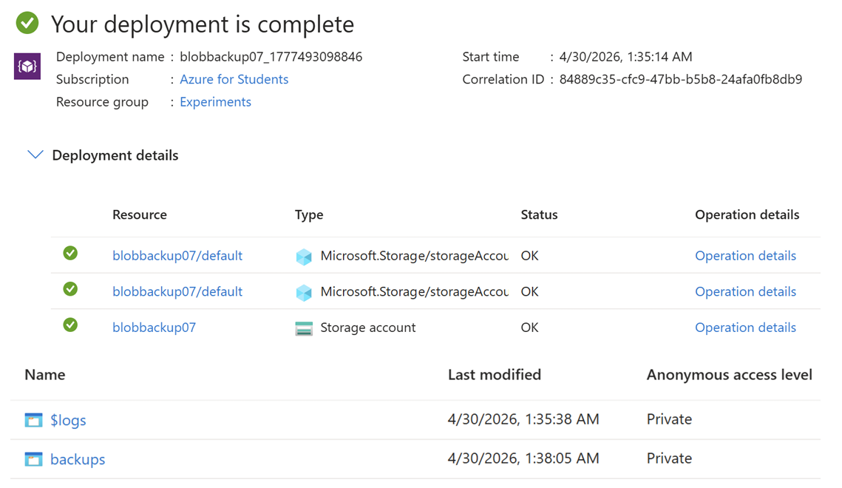
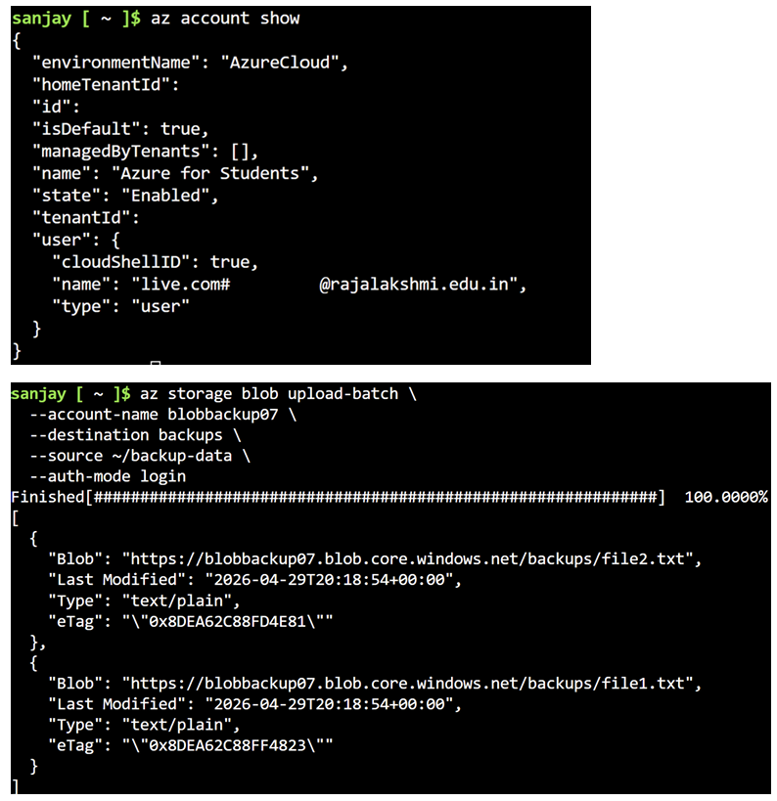

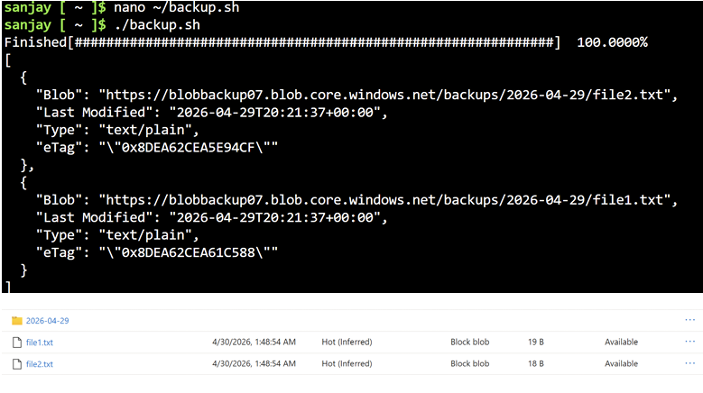

Result:
Successfully implemented automated backup using Azure Blob Storage with scheduling.

EXPT NO. 5 – VPS / VIRTUAL MACHINE SETUP AND LINUX CONFIGURATION

Aim:
To provision a Virtual Private Server (VPS) or create a virtual machine using virtualization software such as VirtualBox or VMware Workstation, install a Linux operating system, and configure network settings including IP address, subnet mask, gateway, and DNS.

Theory:
A Virtual Private Server (VPS) is a virtualized environment that acts like a dedicated server. It can be hosted on cloud platforms or created locally using virtualization tools.
Virtualization software such as:
- VirtualBox
- VMware Workstation
...allows running multiple operating systems on a single physical machine.
Linux distributions like:
- Ubuntu
- CentOS
- Debian
...are commonly used due to stability, security, and open-source nature.

Procedure:
STEP 1: Install Virtualization Software
Option A: Install VirtualBox
- Download from official website
- Install with default settings
Option B: Install VMware Workstation
- Download installer
- Follow installation wizard

STEP 2: Create Virtual Machine
In VirtualBox:
- Open VirtualBox → Click New
- Enter:
Name: LinuxVM
Type: Linux
Version: Ubuntu (64-bit)
- Allocate:
RAM: 2 GB (minimum)
CPU: 1–2 cores
- Create Virtual Hard Disk:
Type: VDI
Size: 20 GB

STEP 3: Attach ISO File
- Download ISO (e.g., Ubuntu)
- Go to VM Settings → Storage
- Attach ISO file

STEP 4: Install Linux OS
- Start VM
- Select Install Ubuntu
- Follow steps:
Language selection
Keyboard layout
Installation type (Normal)
Create username & password
- Click Install
- Restart VM after installation

STEP 5: Configure Network (Automatic - DHCP)
Check IP:
ip a

Check connectivity:
ping google.com

STEP 6: Configure Static IP Address
Edit Netplan config:
sudo nano /etc/netplan/01-netcfg.yaml

Example configuration:
network:
version: 2
ethernets:
enp0s3:
dhcp4: no
addresses: [192.168.1.100/24]
gateway4: 192.168.1.1
nameservers:
addresses: [8.8.8.8, 8.8.4.4]

Apply changes:
sudo netplan apply

STEP 7: Verify Network Configuration
Check IP:
ip a
Check gateway:
ip route
Test DNS:
ping google.com

STEP 8: (Optional) VPS on Cloud
Instead of local VM, you can use:
Microsoft Azure
Amazon EC2
Steps:
- Create VM instance
- Select Linux image
- Configure networking
- Connect via SSH

Output:

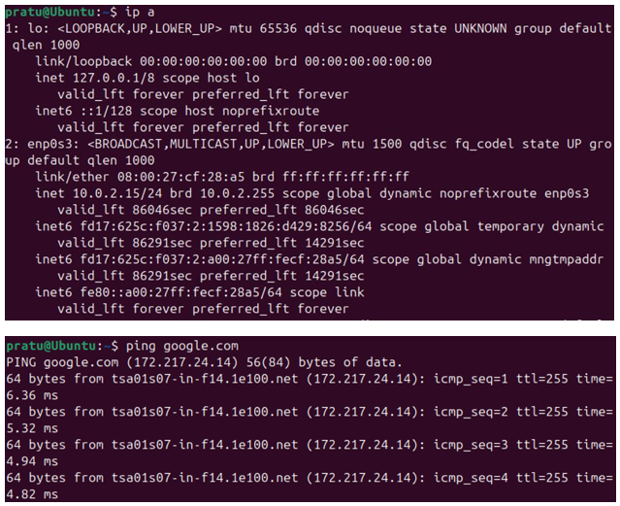
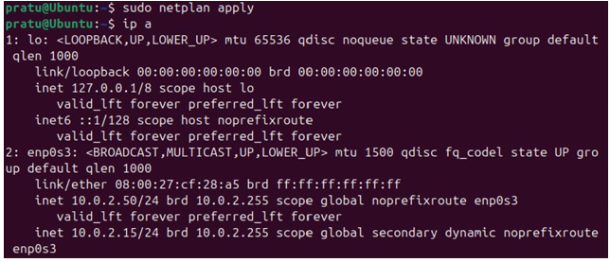

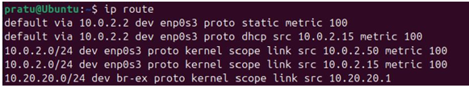
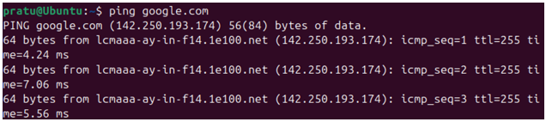

Result:
Successfully created a virtual machine, installed Linux OS, and configured network settings including IP address, gateway, and DNS.

